# Designing Version 3 HCR Probes

This protocol allows you to design your own HCR probes from a known mRNA sequence using R Studio.

## Requirements

* Snapgene Viewer (freely available at [www.snapgene.com/products/snapgene_viewer](http://www.snapgene.com/products/snapgene_viewer))
* R and R Studio installed with the following packages
  + Stringr
  + Plyr

## Obtaining mRNA Sequence

Using NCBI Gene (<https://www.ncbi.nlm.nih.gov/gene>) search for the gene you are interested in, followed by the species name. In this case, Tbxta (Ntla) from Zebrafish

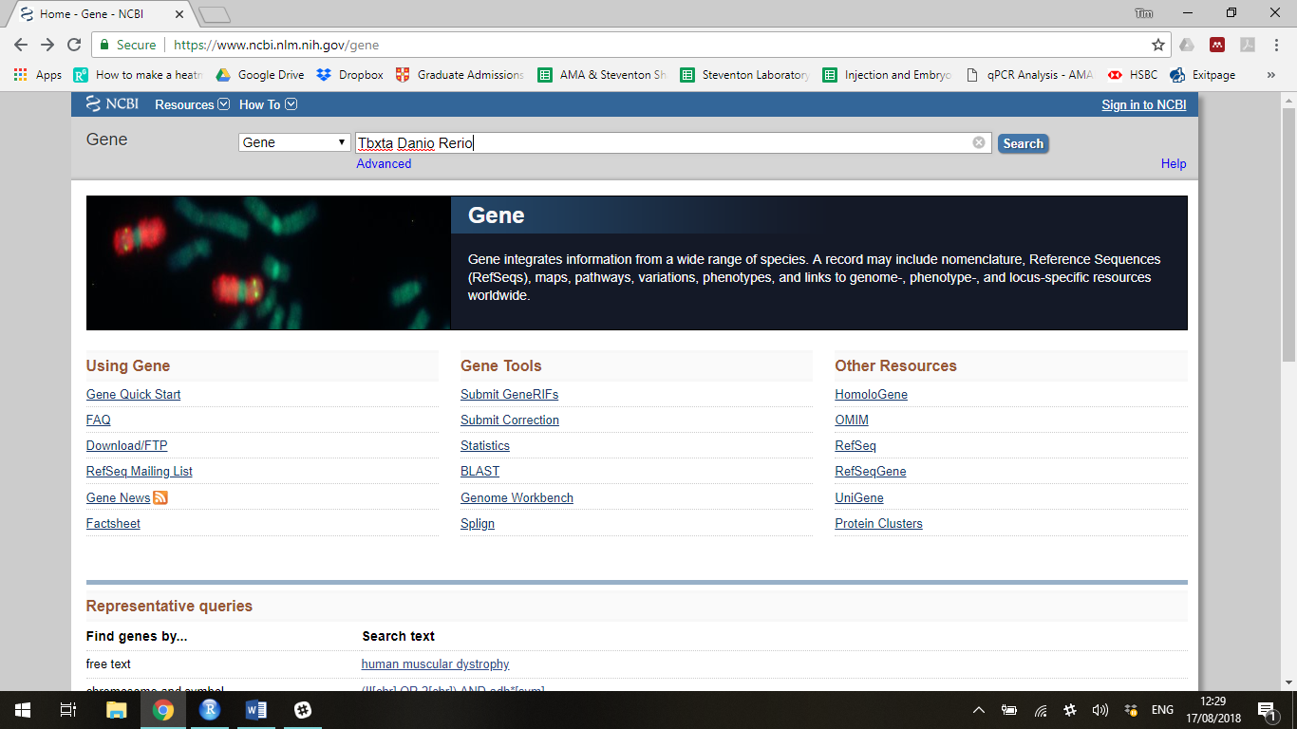

Clicking search takes you to the search results page

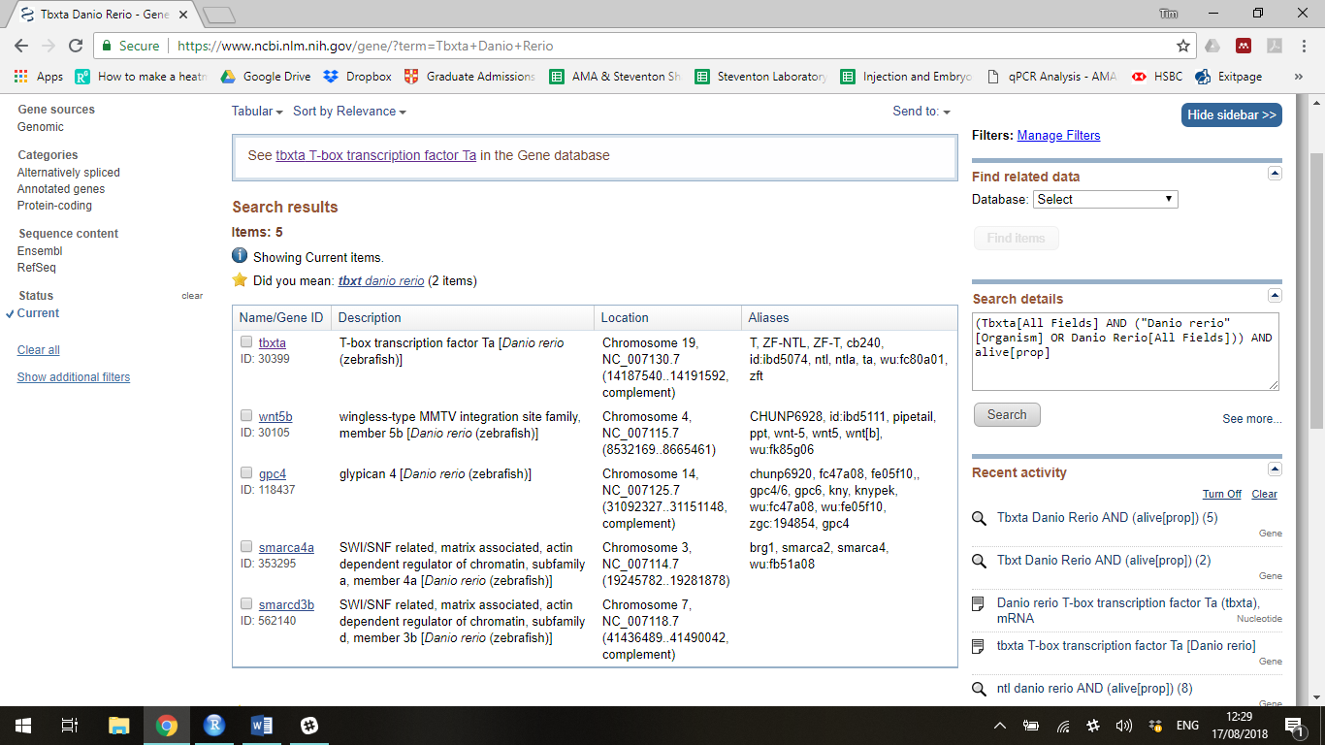

Select the gene you are interested in. For Tbxta this is the first hit. Click the gene name. This takes you to the details page regarding that gene. Scroll down the page to the part named “mRNA and Protein(s)”

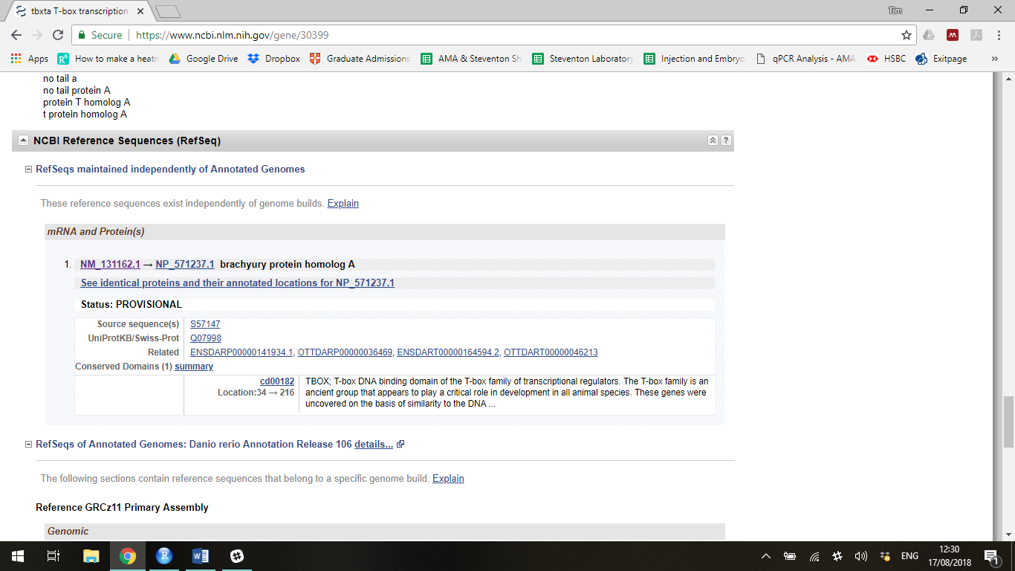

Select the mRNA RefSeq number which here is NM_131162. This takes you to the mRNA RefSeq entry page.

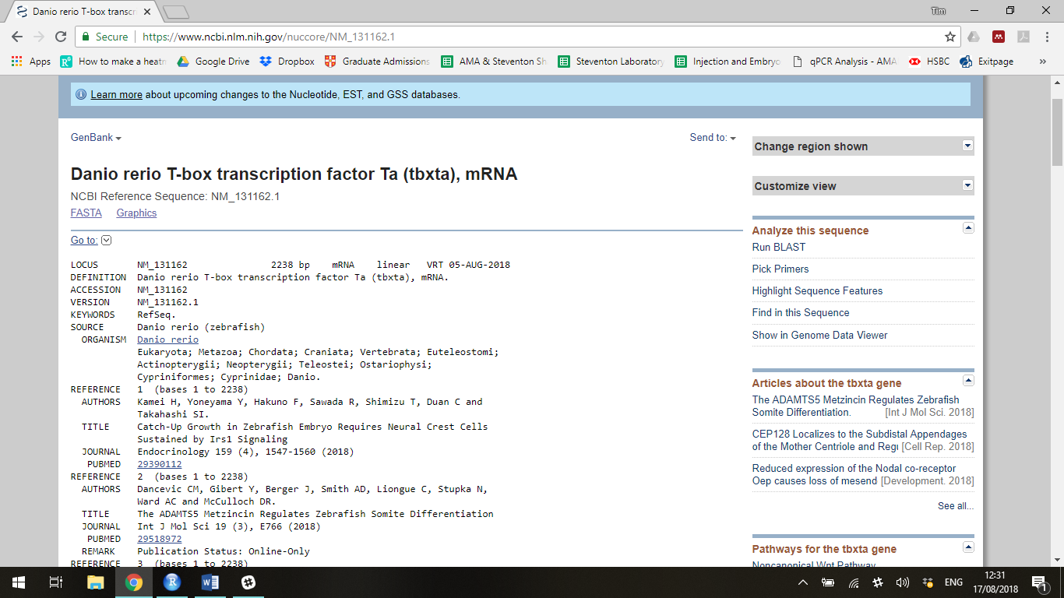

Now click FASTA to view the sequence in FASTA format

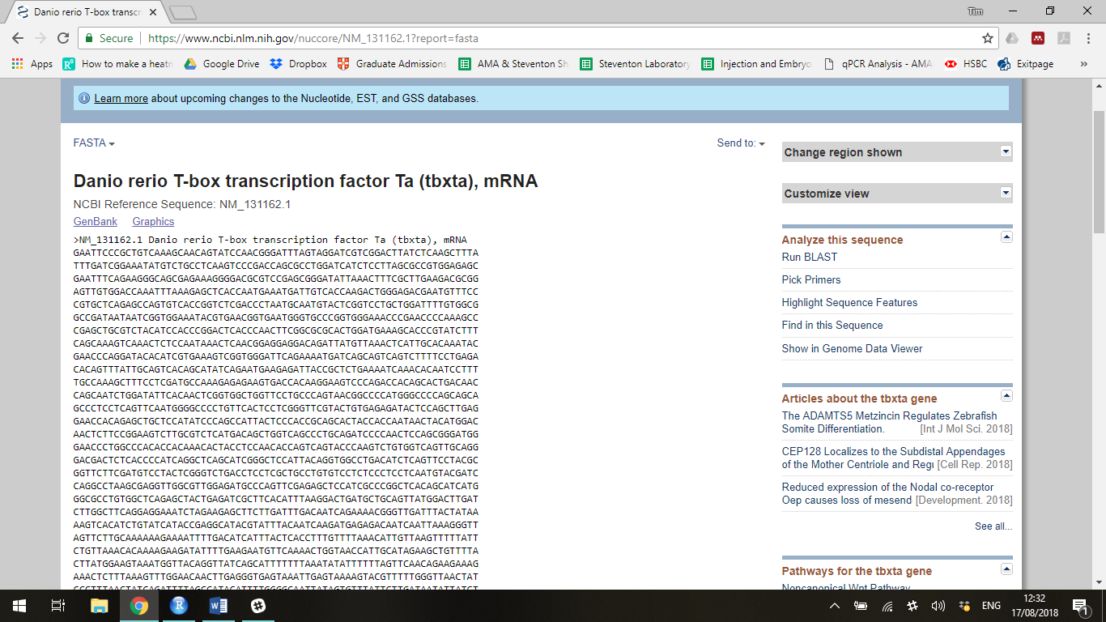

Copy the entire FASTA format, including the header line “>NM_131162.1 Danio rerio T-box transcription factor Ta (tbxta), mRNA”.

Open Snapgene Viewer

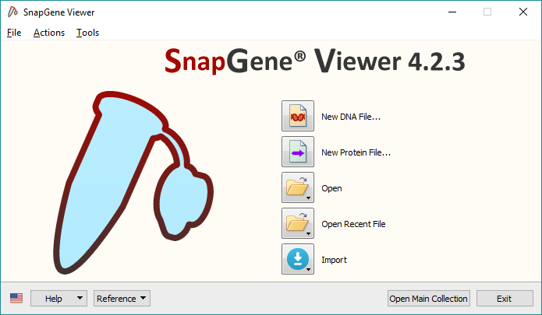

Click New DNA File and paste the entire mRNA sequence into the box. The title line with automatically transfer to the filename box. Messages about transferring features may appear but these can be ignored. You do not require a free trial of the paid software. Check the linear option is selected in Topology. You can also rename the file if required.

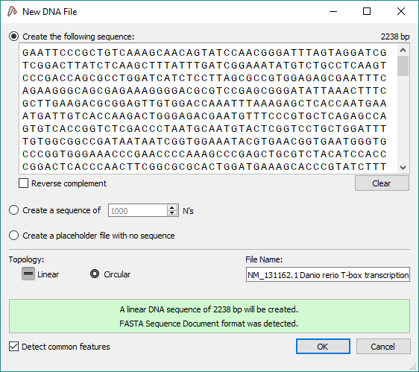

Click OK

This generates a mRNA linear sequence. You can hide the restriction sites by clicking on the Show Enzymes button on the top left of the screen (see arrow).

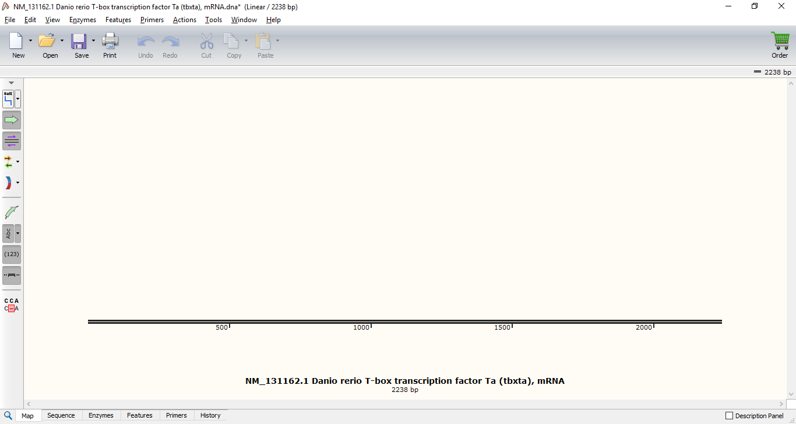

Save this file into a new folder in the lab protocols folder called (Tbxta V3 Probes). Make the gene name match the gene you are designing probes for.

## Designing Probes

Now copy the R File called “Version 3 Probe Synthesis_TF” into this new folder. Rename the R file “Probe Design <GENE NAME>_<INITIALS>”. Do not work directly in the master file. You should only edit this new copy of the script you have generated

Open this new R File. It should open in R Studio using the Notepad format

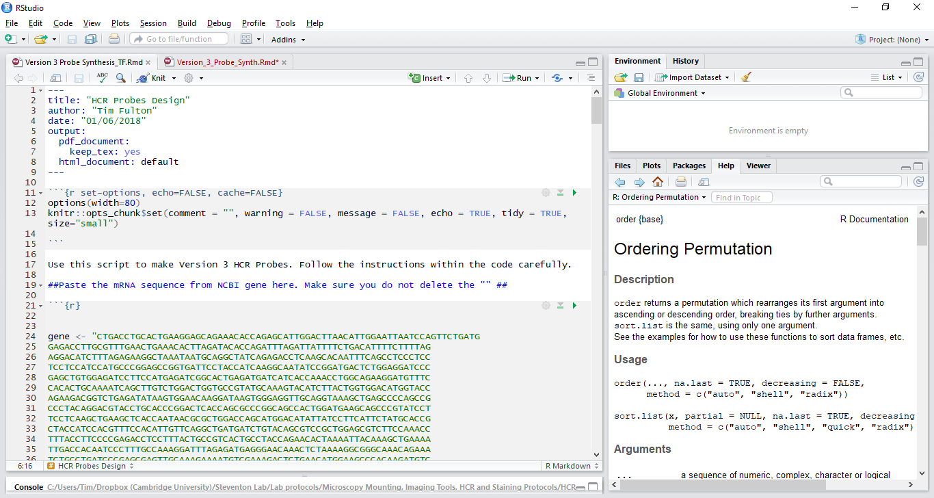

This R script requires little human interaction. To begin the script, scroll to line 24 and replace the gene sequence with the mRNA sequence of the gene you are interested in (this should be the same as the one you made a snapgene file of). Ensure you replace all the sequence present in the original file but do not remove the “ “ which surround the sequence, nor change the gene <- part. Do not worry if your gene sequence has spaces inside it as these will be removed.

Now run each chunk of code one at a time using the Run Current Chunk option under Run. Click at the top of each chunk then select run current chunk. Do not run the entire script at once as this will generate non-specific probes.

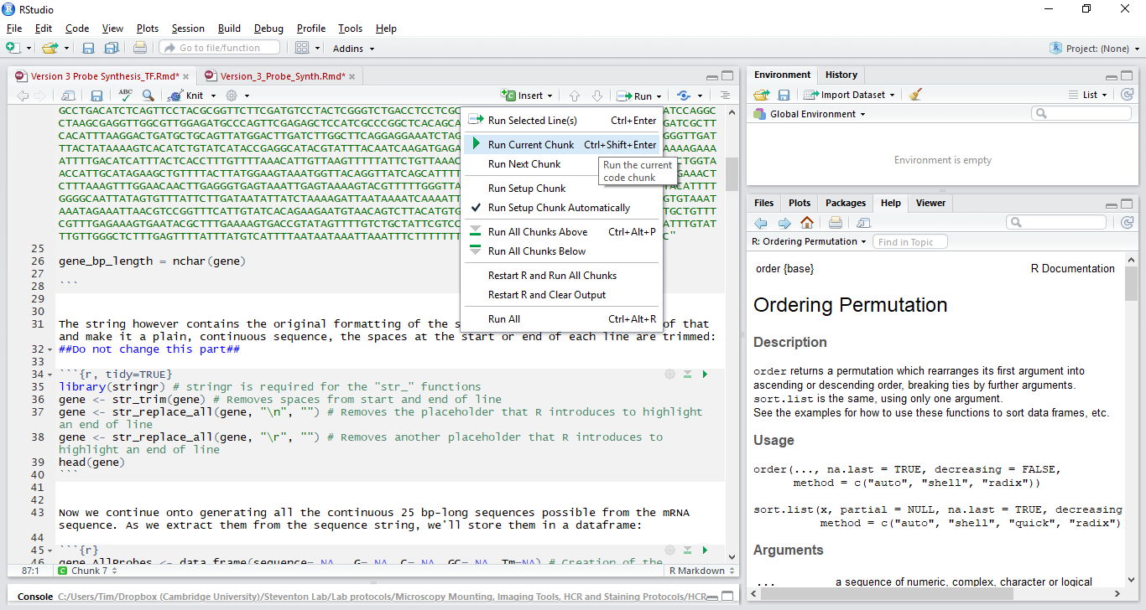

Continue running each chunk until you get to line 88.

In the folder containing the R Script you are running and the snapgene file you should now find a text file called “geneProbesFiltered.txt”. Open this file. It contains all the permissible probe sequences in order from start to finish of the mRNA.

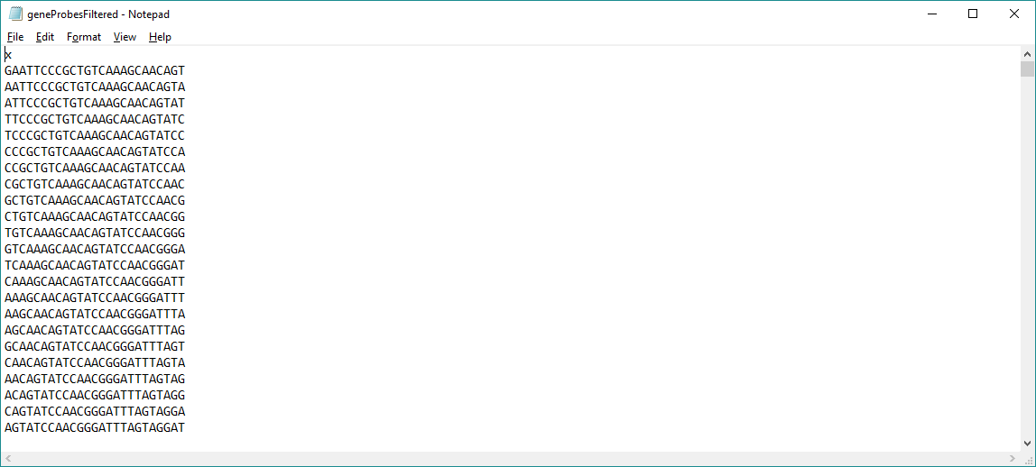

You want to make 5 pairs of probes. The pairs of probes must lie 2 nt apart from one another on the mRNA sequence. You also want to make probes that equally span the entire gene sequence and do not lie on the very extreme ends of the mRNA sequence. Avoid making probes which sit on repetitive sequences or on the polyA tail.

Select a sequence from the text file and, using Control F, find this sequence in the mRNA sequence on Snapgene. You may want to turn the snapgene view into Sequence using the tab at the bottom of the screen.

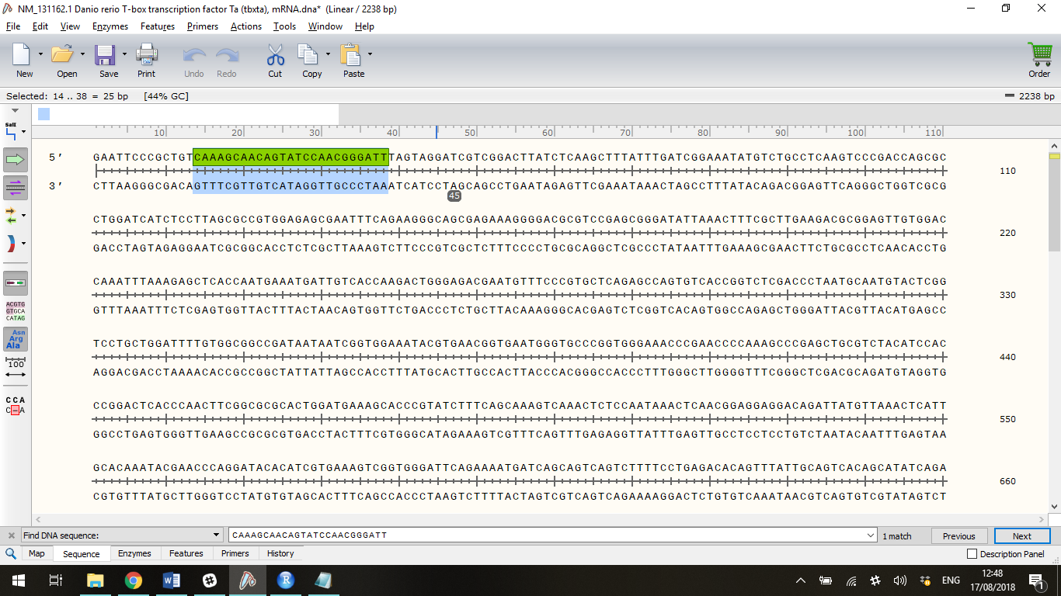

With the sequence selected, go to Features, Add Feature. Name this sequence Probe 1. Click OK

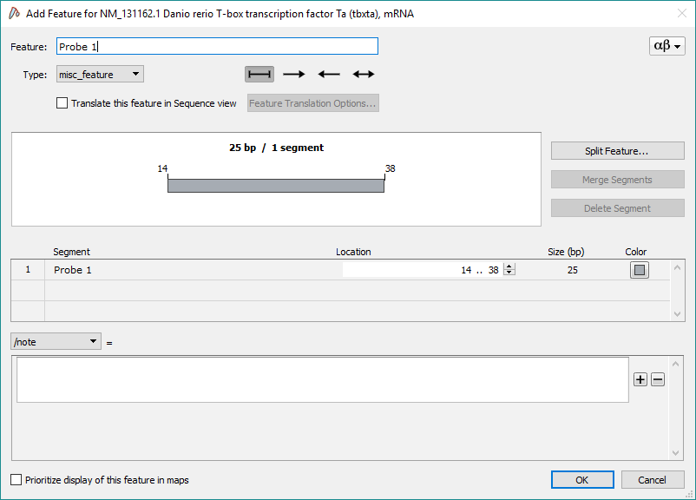

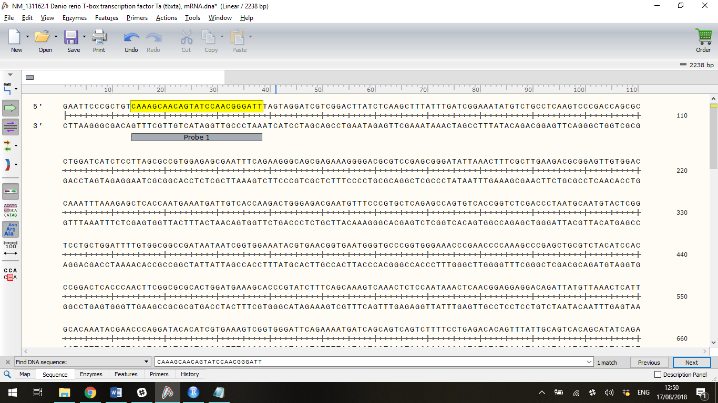

Now select the 25nt sequence starting 2nt after the first probe by clicking and dragging. The selection tool tells you how many nucleotides have been selected.

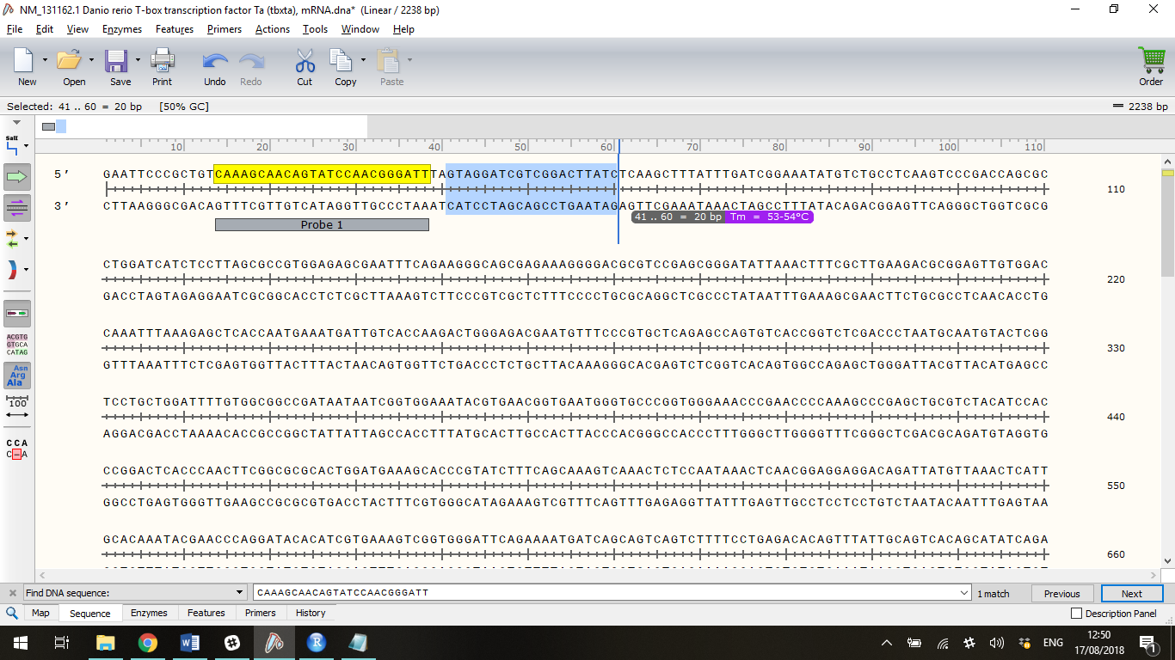

Using Control C, copy this sequence and then use Control F to identify if it is present in the text file of permissible probes. Remember that a text file can only be searched in a defined direction so you may need to change the direction of the search if you yield no results.

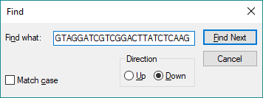

Select this whole sequence and refind it in snapgene to confirm it is the correct sequence

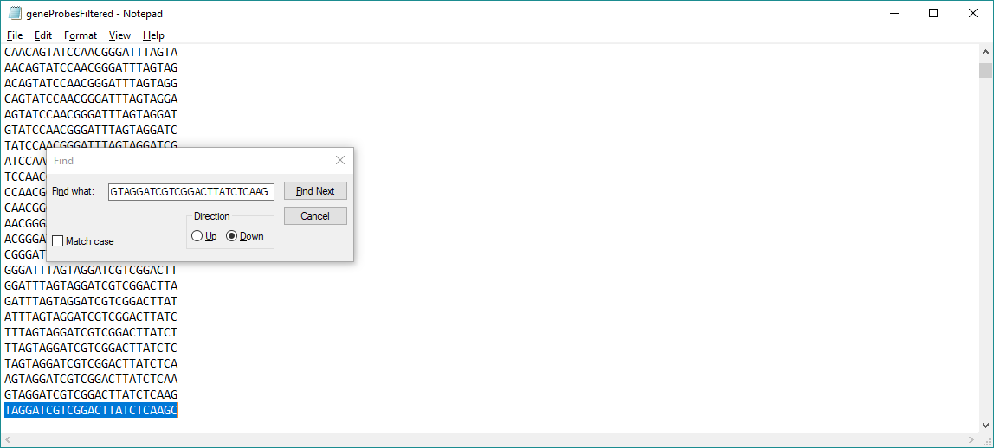

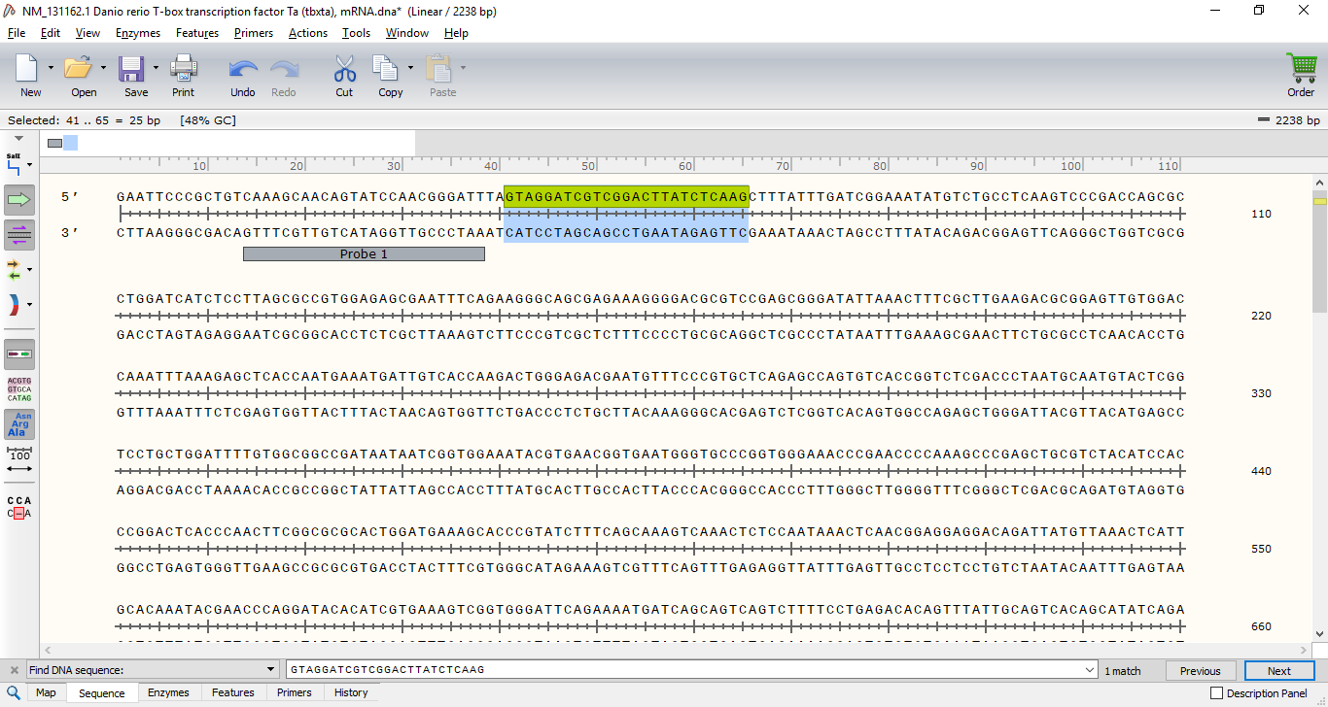

Now add this as the next feature, called Feature 2. This is a probe pair. Repeat this a further 4 times to make a total of 5 probe pairs. Mark each onto the gene map using the feature tool. You can view how spaced out your probes are by returning to the map view at the bottom of the Snapgene viewer window.

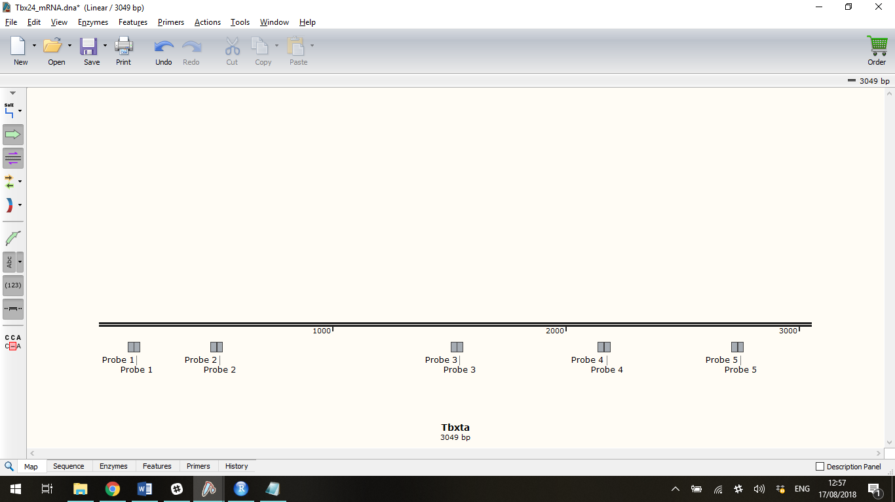

Now you have made the probe sequences, you can add the initiator sequences by returning to the R script. Scroll down to line 92. Carefully copy each probe sequence (by clicking on the feature in Map view and then using Control C) and paste the sequence into the first space in the R Script. Replace any probe sequence already present. Ensure that the odd probes (Probe 1, 3, 5, 7 and 9) go on the left of the string and the even probes (Probe 2, 4, 6 and 8) go on the right hand side. Be careful not to remove any commas or “ “

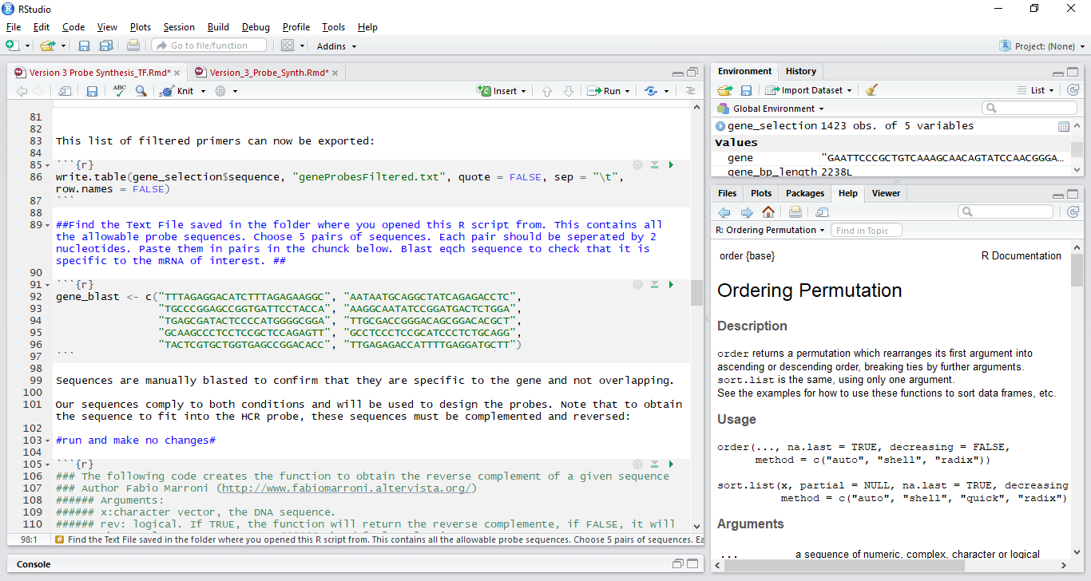

Now click at the start of line 92. Click on the run dropdown menu and then select “Run all chunks below”

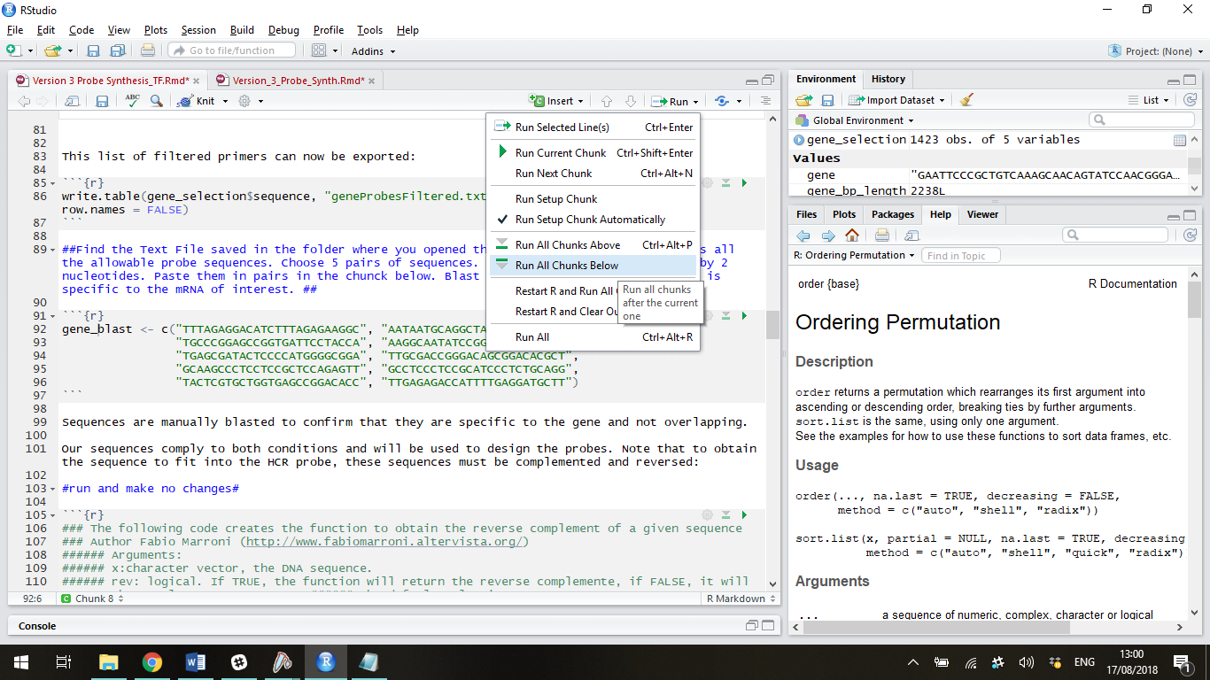

This will generate 5 more text files which contain the probe sequence you chose plus the addition of the spacer and initiator for the various different hairpins (B1, B2, B3, B4, and B5). You can now select the probe set you want and order these sequences directly from Sigma Aldrich in the same way you would a DNA primer.

Ensure you save the R script to generate a record of how the probes were synthesised.

It is recommended that you order the minimum amount of probe possible and desalted seems to be an effective purification method of Version 3 HCR. Name probes in the following way <GENE><Bx><ODD/EVEN>_<Pair Number>. For example

Ntl B4 Even_1

Ntl B4 Odd_1

Ntl B4 Even_2

Ntl B4 Odd_2

Ntl B4 Even_3

Ntl B4 Odd_3

Ntl B4 Even_4

Ntl B4 Odd_4

Ntl B4 Even_5

Ntl B4 Odd_5

## Using Probes

When the probes arrive, dilute to 100µM as detailed on the datasheet supplied from Sigma. Then mix all the Odd probes together in equal volumes. Do the same for the even probes. This makes a 5 times dilution of each probe to a 20µM stock. The working concentration of probes is 2µM so when using the probe you can either first dilute the 20µM stock a further 10 times or add 0.1µL per 500µL of buffer (dilution is preferable for accuracy).

Store buffers in nuclease free water at -20